Project Name: |  |  |  |  |  |  | Work Area
Date / Time |  |  |  |  |  |  | MSRA Number
PTW Ref |  |  |  |  | Name of person conducting Brief
Additional PPE Required
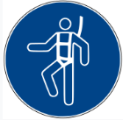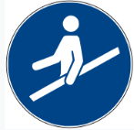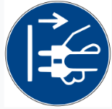

Additional Hazards Identified for the Activity
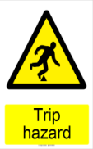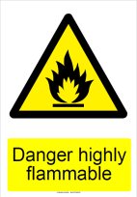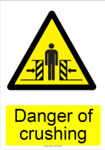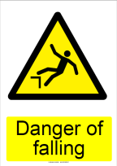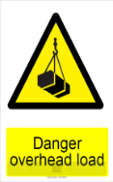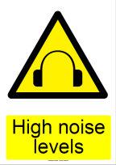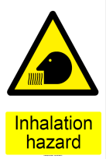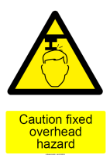

Precautions for Additional Hazards
COSHH Items to be used
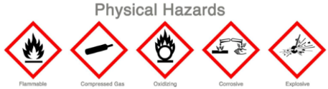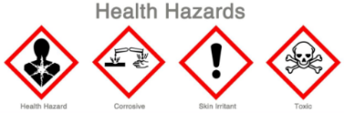

Plant/ Equipment/Tools to be used
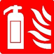
People at risk
Employees
DAN
Visitors
Details of Employees Performing the Activity
Sr. No | Name |  |  | Trade |  | Company |  | Induction No |  | Signature
1.
2.
3.
4.
5.
6.
7.
8.
9.
10.
11.
12.
13.
14.
15.
16.
17.
18.
19.
20.
Declaration that the employee supervising the works confirms that all Procedures and Hazards of the Activity are CLEAR, COMMUNICATED, CONTROLLED and CHECKED.
Name |  |  |  | Notes:
Signature

